**Steps to use the SurveyApp:**

1. Install the app from the provided apk file
2. Turn on **WiFi** or **data connection**
3. Turn on the **GPS**.

Go to Settings > GPS > Mode and check if “High Accuracy” is selected.

(**N.B.** In most of the Samsung devices, it’s automatically pre-selected, see the screenshot below)

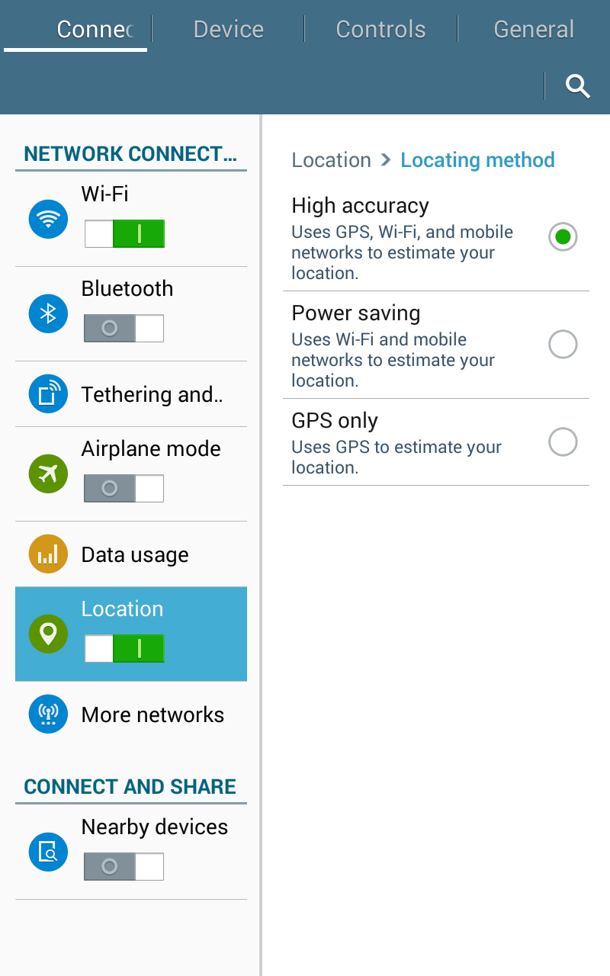

1. The user has to login first by verifying phone number

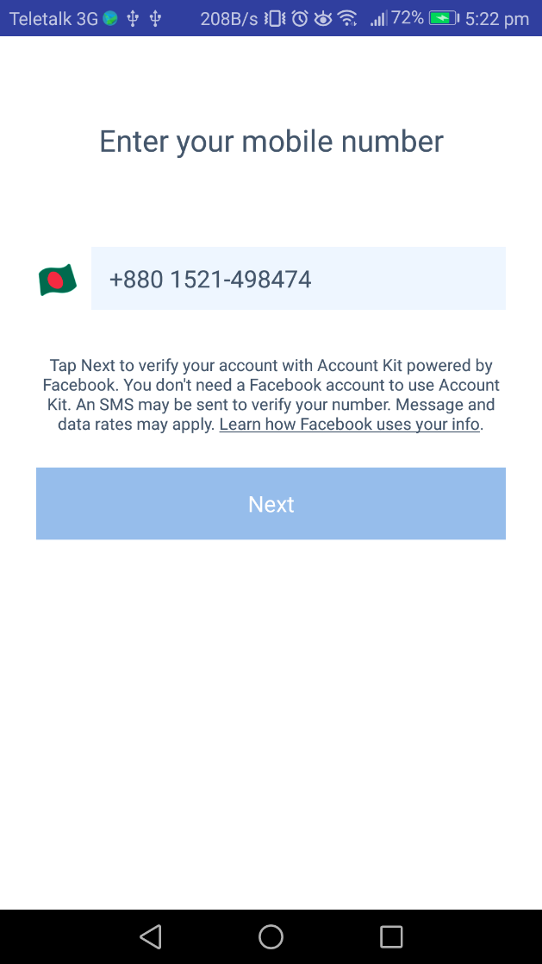

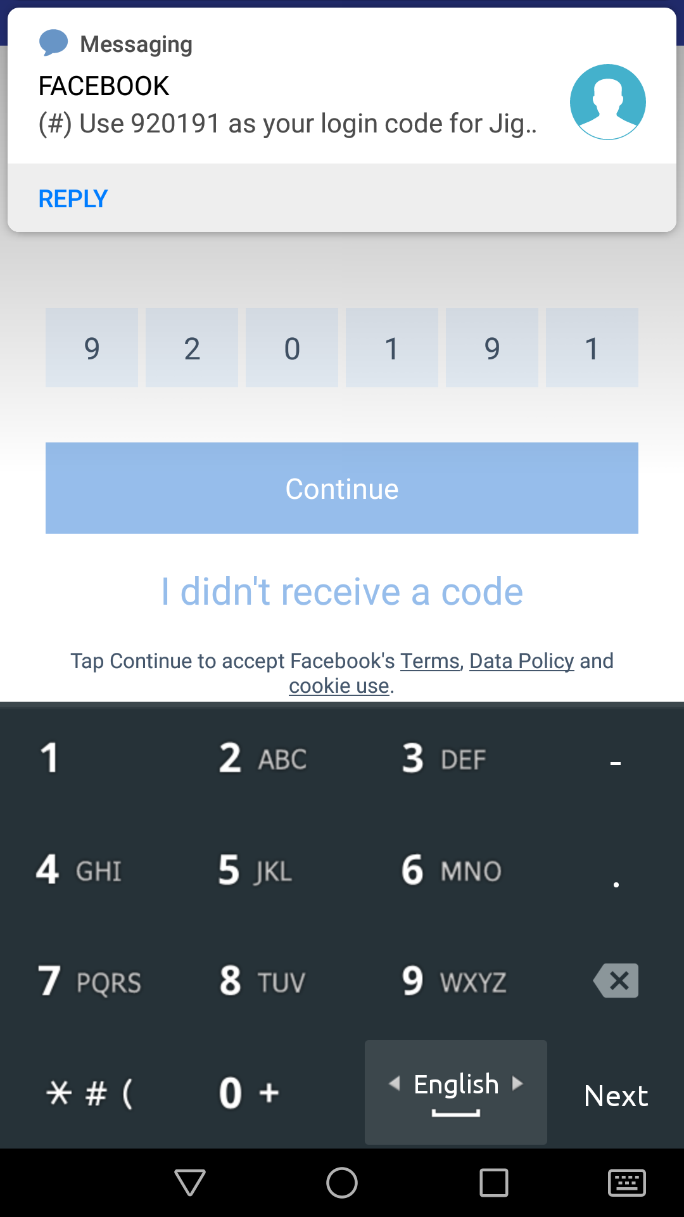

1. Input your name like this:

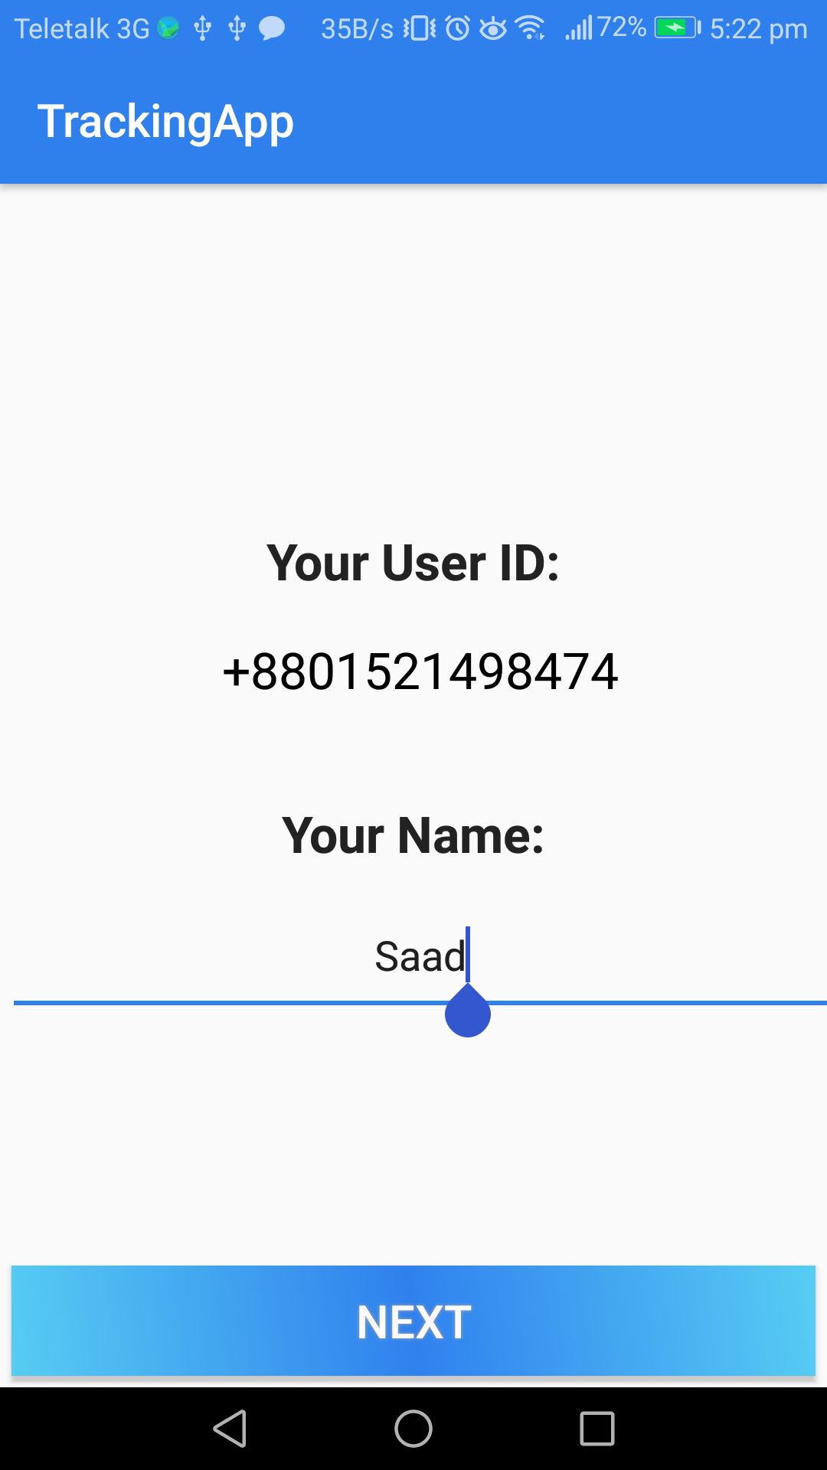

1. Then click on “Start Tracking”

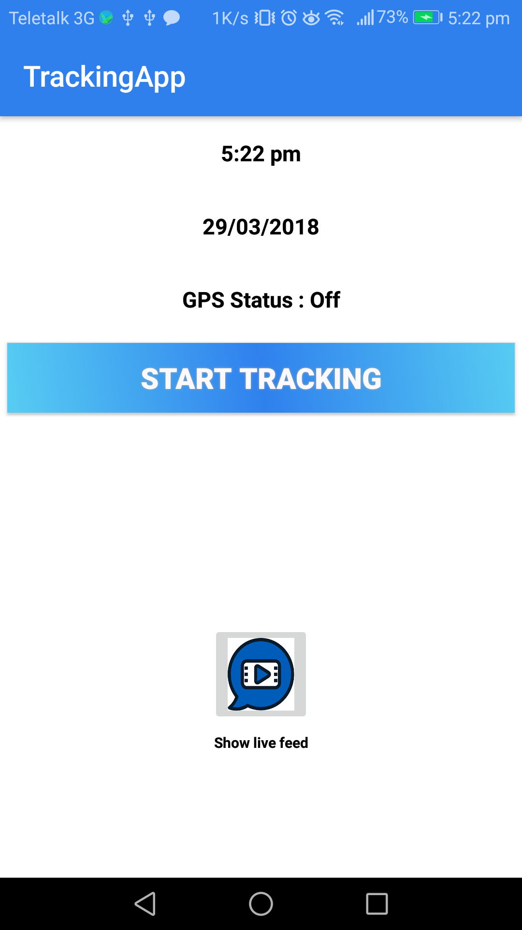

1. Press OK to allow the app to get your location:

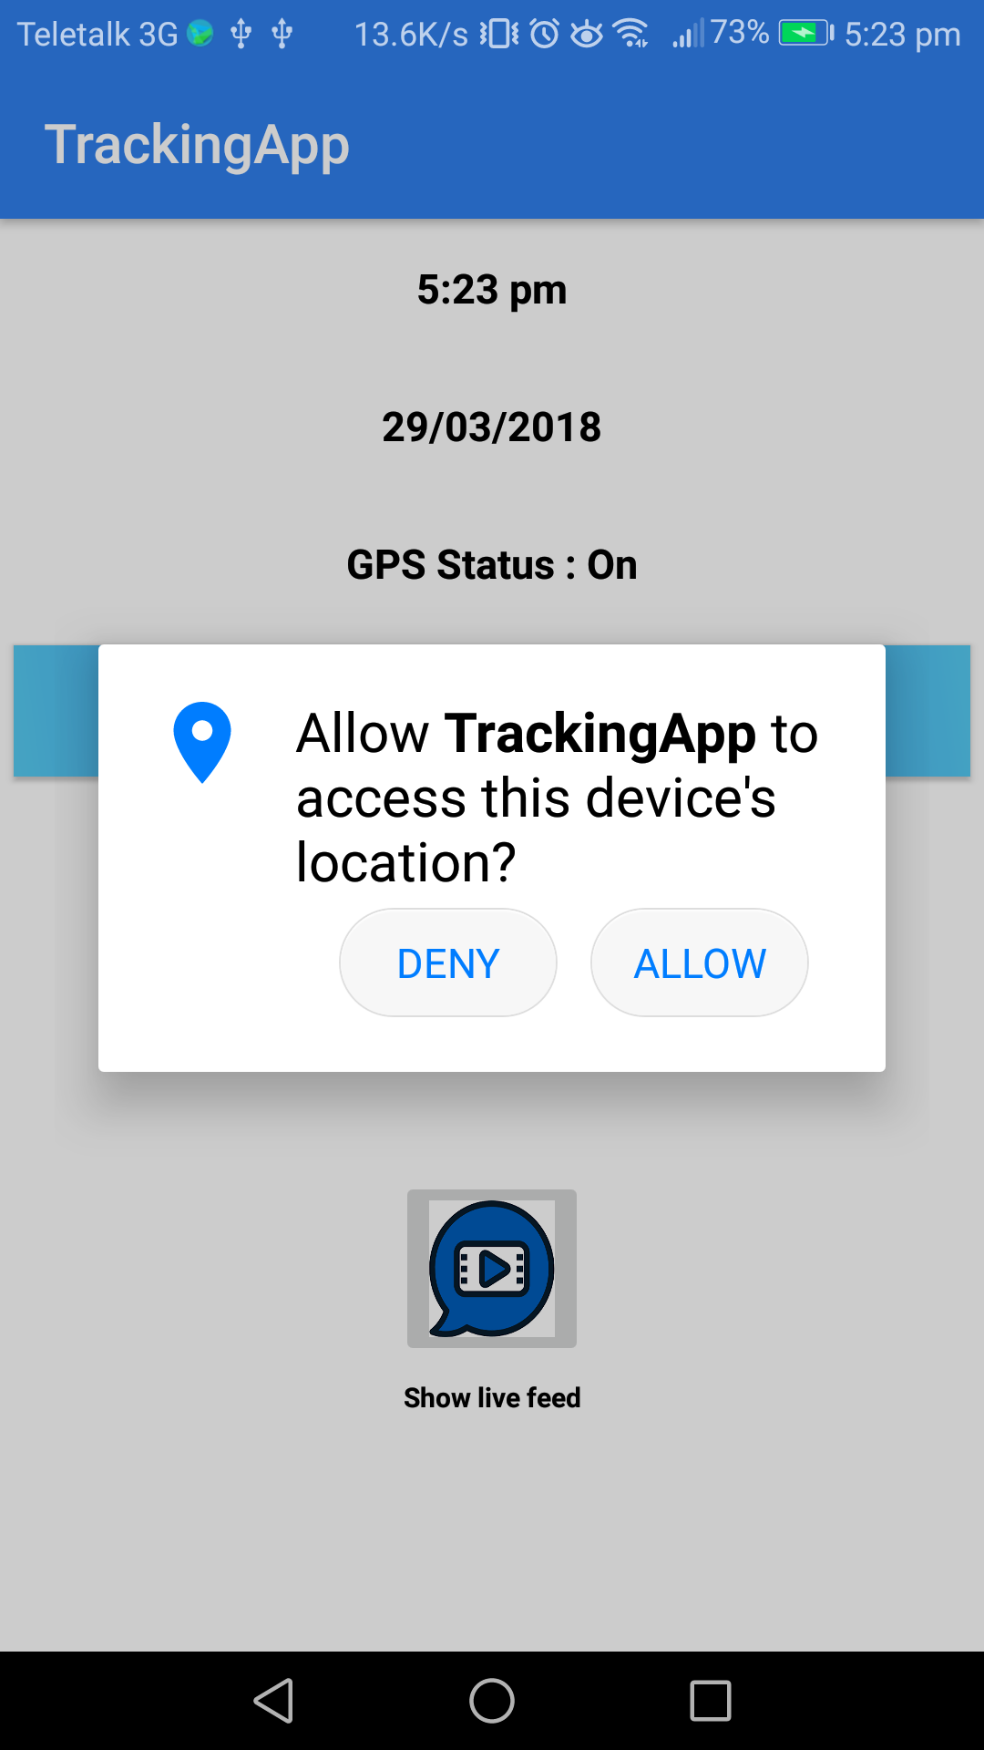

1. Press “Stop Tracking” and confirm it.

